E-FARMING

Sub: “Yantrik Krishi”

Team:

Sargam Badyal 10bce0385

Sadhana Muthu Kumar 10bce0100

Aditi Mahajan 10bce0003

**Aim:**

E-farming is an emerging field focused on the enhancement of agricultural and rural development through improved information and communication processes. It involves the conceptualization, design, development, evaluation and application of innovative ways to use information and communication technologies (ICTs) in the rural domain, with a primary focus on agriculture. We aim at building a realistic technology that helps the farmers to be aware about the modern techniques and equipments for operation which will make their farming methods efficient.

**Objective:**

1. Enhance sustainable agricultural development
2. Bring the farmers close to the technology
3. Keep the farmers up to date with the latest advancements in the field of farming
4. Make a unified portal for farmers to buy high yield variety of seeds, manure and equipment at genuine rates.
5. Help the farmers solve the problems faced during the cultivation, irrigation, development and harvesting stages of the crop.
6. Train the farmers to use the website using a basic tutorial
7. Information spread in native language to improve understanding
8. One portal for marketing the products at the prize they want with active updating
9. Provide the security to crops by providing the certification and insurance to crops which they can apply for from the site itself.
10. Most importantly, the farmers can also upload the pictures of the crops which will be analyzed by our experts and the response will be send through SMS/ email.

**Problem statement:**

Most of the farmers in India are still not aware about the technological advancements in farming thus are not able to fully avail the benefits. Moreover they also remain poor because of lack of information to various improvement plans of the government. Farmers are often deceived and made to sell their crops at cheaper rates. But this forum will help the farmers to enjoy their rights and bring prosperity in their lives.

**Process model:**

**RAD Process model:**

Rapid application development is a software development methodology, which involves iterative development and the construction of prototypes. It is a merger of various structured techniques, especially the data driven Information Engineering with prototyping techniques to accelerate software systems development

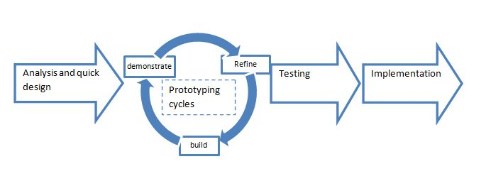

**Justification:**

1. No extensive pre-planning
2. Software is written much faster, and is easier to change requirements.
3. Can work in collaboration with the user(self) which increases the chances of easy approval of project
4. Software reuse is possible
5. Small team structure
6. Flexible and adaptable to change
7. Prototyping helps the users to see if the requirements are met.
8. It has short development cycles thus instant results
9. Overall reduction in project risk
10. Pareto's 80 - 20 Rule usually results in reducing the costs to create a custom system.
11. Relatively newer model and good to analyze its usefulness.

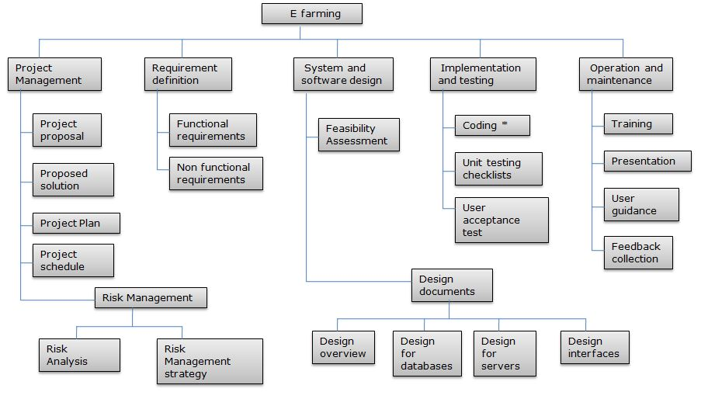**Work breakdown structure:**

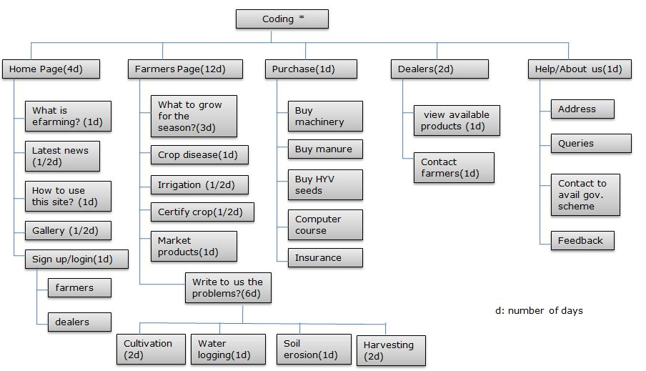

**Gant chart:**

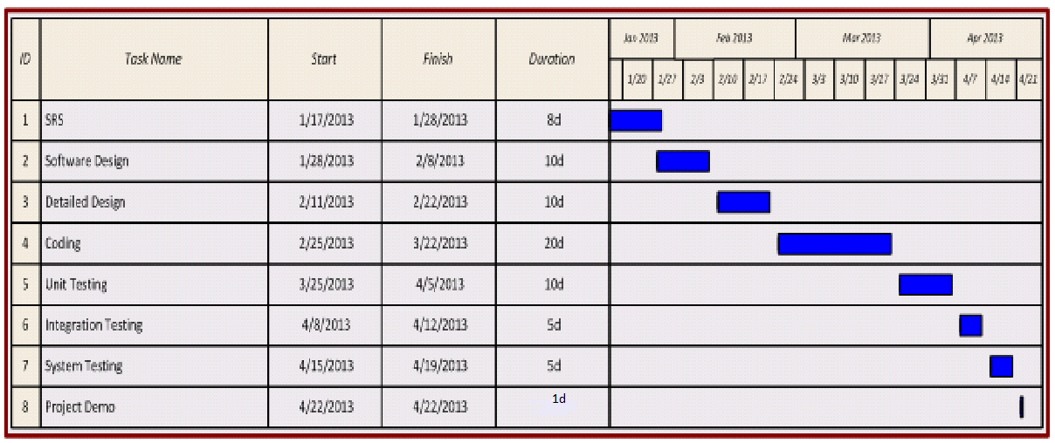

**SRS**

1. Introduction

**Methodology:**

We are using RAD model for the development of our project.

**Requiremnet planning:** Planning and anaysis of the system is done through different phases of the system development life cycle(SDLC). Users,managers and staff agrees on needs,project scope,constraints and system requirements.

**User design:** user design is a continuos process that allows the users to understand,modify and eventually approve a working model of the system that meets their requirements.

**Construction:** focus on program and application development task similar to the SDLC.Its tasks are programming and application development,coding,unit integration and system testing.

**Cutover:** Its tasks are data conversion,full scale testing,system changeover,user training.

**Purpose:**

E farming: project “ yantrik Krishi” will help the farmers to have a unified portal yo catter to their farming requiremnts in all ways.

The farmers living in remote areas can get updated information about new methods and techniques in no time. In this site where all the information about agriculture comes handy also problems are easily solved using our problem addressal portal.It helps the farmer to practice farming in the most advanced and haselfree way.

**Scope:**

There are four main stake holders for “Yantrik Krishi”

1. Farmers
2. Experts
3. Admin
4. Wholesale

* All the users have their own profiles.
* Farmers can get information from the site reguarding what crops should they grow depending upon they season and topology.
* Farmers can ask queries to the experts about crop diseases, water logging, soil erosion, organic manure, fertilization, irrigation etc.
* Farmers can buy advanced machinery, seeds, fertilizers and insurance for their crops.
* Admins approve the users(farmers and wholesaler) checking their ID’s and verifying the accouts and also approve the scale of the farmer.They can add/delete the users and grant permissions to users, experts and wholesaler.
* Experts can maintain their accounts and answer the queries of the farmers.
* Wholesale can buy the products from the farmers.

**Definitions, Acronyms and Abbreviations**

Admin: Administrator

WAMP: Windows, Apache, MySQL, PHP/Perl/Python

MYSQL: My Structured Query Language

RDMS: [Relational Database Management System](http://en.wikipedia.org/wiki/Relational_database_management_system)

YK: Yantrik Krishi

JS: Java script

PHP: PHP: Hypertext Preprocessor

HTML: Hyper Text markup language

HTTP: HyperText Transfer Protocol

HTTPS: HyperText Transfer Protocol Secure

CSS: Cascading style sheets

AJAX:  Asynchronous JavaScript and XML

**Tools used:**

**Application Architecture: PHP, HTML, Javascript, ajax**

**PHP:** PHP is an open source [server-side scripting](http://en.wikipedia.org/wiki/Server-side_scripting) language designed for [Web development](http://en.wikipedia.org/wiki/Web_development) to produce [dynamic Web pages](http://en.wikipedia.org/wiki/Dynamic_Web_page). It is one of the first developed server-side scripting languages to be embedded into an [HTML](http://en.wikipedia.org/wiki/HTML) source document rather than calling an external file to process data. The code is [interpreted](http://en.wikipedia.org/wiki/Interpreter_(computing)) by a Web server with a PHP processor module which generates the resulting Web page. It has also evolved to include a [command-line interface](http://en.wikipedia.org/wiki/Command-line_interface) capability and can be used in [standalone](http://en.wikipedia.org/wiki/Computer_software) [graphical applications](http://en.wikipedia.org/wiki/Graphical_user_interface).[[2]](http://en.wikipedia.org/wiki/PHP#cite_note-2) PHP can be deployed on most Web servers and also as a standalone [shell](http://en.wikipedia.org/wiki/Shell_(computing)) on almost every [operating system](http://en.wikipedia.org/wiki/Operating_system) and [platform](http://en.wikipedia.org/wiki/Computing_platform), free of charge.

**HTML:** It is the main [markup language](http://en.wikipedia.org/wiki/Markup_language) for displaying [web pages](http://en.wikipedia.org/wiki/Web_page) and other information that can be displayed in a [web browser](http://en.wikipedia.org/wiki/Web_browser). HTML is written in the form of [HTML elements](http://en.wikipedia.org/wiki/HTML_element) consisting of *tags* enclosed in [angle brackets](http://en.wikipedia.org/wiki/Angle_brackets)(like <html>), within the web page content. The purpose of a [web browser](http://en.wikipedia.org/wiki/Web_browser) is to read HTML documents and compose them into visible or audible web pages. The browser does not display the HTML tags, but uses the tags to interpret the content of the page.HTML elements form the building blocks of all [websites](http://en.wikipedia.org/wiki/Website).

**Javasript:** JavaScript (JS) is an open source [client-side](http://en.wikipedia.org/wiki/Client-side_scripting) [scripting language](http://en.wikipedia.org/wiki/Scripting_language) commonly implemented as part of a [web browser](http://en.wikipedia.org/wiki/Web_browser) in order to create enhanced [user interfaces](http://en.wikipedia.org/wiki/User_interface) and dynamic [websites](http://en.wikipedia.org/wiki/Website).JavaScript is [prototype-based](http://en.wikipedia.org/wiki/Prototype-based) scripting language that is [dynamic](http://en.wikipedia.org/wiki/Dynamic_language), [weakly typed](http://en.wikipedia.org/wiki/Weak_typing) and has [first-class functions](http://en.wikipedia.org/wiki/First-class_functions). It uses [syntax](http://en.wikipedia.org/wiki/JavaScript_syntax) influenced by the language [C](http://en.wikipedia.org/wiki/C_(programming_language)).

**Ajax:** It is a group of interrelated [web development](http://en.wikipedia.org/wiki/Web_development) techniques used on the [client-side](http://en.wikipedia.org/wiki/Client-side) to create asynchronous [web applications](http://en.wikipedia.org/wiki/Web_application). With Ajax, web applications can send data to, and retrieve data from, a [server](http://en.wikipedia.org/wiki/Web_server) asynchronously (in the background) without interfering with the display and behavior of the existing page. Data can be retrieved using the [XMLHttpRequest](http://en.wikipedia.org/wiki/XMLHttpRequest) [object](http://en.wikipedia.org/wiki/Object_(computer_science)). Despite the name, the use of XML is not required ([JSON](http://en.wikipedia.org/wiki/JSON) is often used instead), and the requests do not need to be [asynchronous](http://en.wikipedia.org/wiki/Asynchronous_I/O).

**Application development tool: Notepad++**

**Notepad++:** Notepad++ is a [text editor](http://en.wikipedia.org/wiki/Text_editor) and [source code editor](http://en.wikipedia.org/wiki/Source_code_editor) for [Windows](http://en.wikipedia.org/wiki/Microsoft_Windows). It aims to be a lightweight and robust editor for a variety of programming and scripting languages. One advantage of Notepad++ over the built-in Windows text editor [Notepad](http://en.wikipedia.org/wiki/Notepad_(Windows)), is that Notepad++ supports [tabbed editing](http://en.wikipedia.org/wiki/Tab_(GUI)), which allows working with multiple open files.

**Web server: WAMP 2.0**

**WAMP:** WAMPs are packages of independently created programs installed on computers that use a [Microsoft Windows](http://en.wikipedia.org/wiki/Microsoft_Windows) operating system.WAMP is an acronym formed from the initials of the operating system Microsoft Windows and the principal components of the package:[Apache](http://en.wikipedia.org/wiki/Apache_HTTP_Server), [MySQL](http://en.wikipedia.org/wiki/MySQL) and one of [PHP](http://en.wikipedia.org/wiki/PHP), [Perl](http://en.wikipedia.org/wiki/Perl) or [Python](http://en.wikipedia.org/wiki/Python_(programming_language)). Apache is a [web server](http://en.wikipedia.org/wiki/Web_server).

**Design tool: CSS**

**CSS:** It is a [style sheet language](http://en.wikipedia.org/wiki/Style_sheet_language) used for describing the[presentation semantics](http://en.wikipedia.org/wiki/Presentation_semantics) (the look and formatting) of a document written in a [markup language](http://en.wikipedia.org/wiki/Markup_language). Its most common application is to style [web pages](http://en.wikipedia.org/wiki/Web_page) written in [HTML](http://en.wikipedia.org/wiki/HTML) and [XHTML](http://en.wikipedia.org/wiki/XHTML), but the language can also be applied to any kind of [XML](http://en.wikipedia.org/wiki/XML) document, including [plain XML](http://en.wikipedia.org/wiki/Plain_Old_XML), [SVG](http://en.wikipedia.org/wiki/Scalable_Vector_Graphics) and[XUL](http://en.wikipedia.org/wiki/XUL).

**Database platform: PHP Myadmin**

**PHP Myadmin:** phpMyAdmin is a [free and open source](http://en.wikipedia.org/wiki/Free_and_open_source) tool written in [PHP](http://en.wikipedia.org/wiki/PHP) intended to handle the administration of [MySQL](http://en.wikipedia.org/wiki/MySQL) with the use of a [Web browser](http://en.wikipedia.org/wiki/Web_browser). It can perform various tasks such as creating, modifying or deleting [databases](http://en.wikipedia.org/wiki/Database), [tables](http://en.wikipedia.org/wiki/Table_(database)), [fields](http://en.wikipedia.org/wiki/Field_(computer_science)) or [rows](http://en.wikipedia.org/wiki/Row_(database)); executing [SQL](http://en.wikipedia.org/wiki/SQL) statements; or managing users and permissions.

**Database Management System: Mysql**

**MySQL:** It is the world's most usedopen source RDBMS as of 2008 that runs as a server providing multi-user access to a number of databases. MySQL is a popular choice of database for use in web applications.

**References:**

* [**http://en.wikipedia.org/wiki/**](http://en.wikipedia.org/wiki/)
* [**http://fullforms.com/**](http://fullforms.com/)
* **http://www.wampserver.com/en/**

**Technologies to be used:**

* RDBMS: For the database management system
* Wamp 2.0: Web development proxy server
* Filezilla: hosting the website
* 5gbfree.com the online free server

2. Overall Description

**Product Perspective:**

Web Application Sphere

Browser

Database management system + database

Database access window /localhost

Web host page management engine

mysql

HTTP/HTTPS

HTTP

HTTP server (plug-ins)

HTTPS

PHP mailer Site

**Software Interface:**

**Client Server:**

Web browsers(preferably Google Chrome), operating system (any)

**Web server:**

Host server(any),WAMP, operating system(any)

**Database server:**

Mysql, phpmyadmin, operating system (any)

**Development end:**

Php,javascript,html,mysql,ajax,css,OS(windows),notepad++(editor),netbeans(optional),css inliner tool(optional)

**Hardware requirements:**

|  |  |  |  |  |
| --- | --- | --- | --- | --- |
|  | Processor | RAM | Disk Space | Additional |
| *Web Browser (Internet Explorer 7+, Firefox 3.5+, Google Chrome 3+, Opera 9+, Safari 3+)* | ***A 800-MHz Intel Pentium III processor or equivalent*** | ***512 MB of RAM (1GB recommended)*** | **100MB** | ***1024 x 768 resolution color display or better (1280 x 800 or 1280 x 1024 recommended)*** |
| WAMP | ***3-GHz Intel Processor or equivalent*** | ***3GB of RAM (4 GB recommended)*** | ***60 GB of available disk space*** | ***PHP Server (version 5.3)***  ***MySQL Server (version 5.x)*** |
| Host server | ***A 800-MHz Intel Pentium III processor or equivalent*** | ***20480MB*** | ***5120MB*** | ***File manager, disk space usage, Mysql databases*** |

**Functional Requirements:**